
FACULTY OF SCIENCE, ENGINEERING AND COMPUTING
School of Computer Science and Mathematics BSc (Hons) DEGREE
IN

CYBER SECURITY

Haned Ali

K2330569

Cyber2U
  - Interactive Email-Based Cybersecurity Awareness Platform
28/03/26
Name of Supervisor
Declaration
I have read and understood the University regulations on plagiarism, and I understand the meaning of the word plagiarism. I declare that this report is entirely my own work. Any other sources are duly acknowledged and referenced according to the requirements of the School of Computer Science and Mathematics. All verbatim citations are indicated by double quota-tion marks (“…”). Neither in part nor in its entirety have I made use of another student’s work and pretended that it is my own. I have not asked anybody to contribute to this project in the form of code, text, or drawings. I did not allow and will not allow anyone to copy my work with the intention of presenting it as their own work.
Date:
Name:

Signature:
Table of Contents
Table of Figures (Figures) 6
Table of Figures (Tables) 6
Glossary of Terms 7
Abstract 8
1. Introduction and Background 9
1.1 Problem context and scale 9
1.2 Aim, objectives and research questions 10
1.3 Scope 10
1.4 Ethical, legal and social issues 11
2. Project Management Strategy 12
2.1 Development workflow 12
2.2 Schedule and milestones 12
2.3 Milestones and deliverables 13
2.4 Risk management and scope control 14
3. Literature Review 15
3.1 Cybersecurity awareness and human factors 15
3.2 Retrieval practice, spacing and feedback 16
3.3 Motivation, self-efficacy and interface design 16
3.4 Authentication usability and privacy-aware analytics 17
3.5 Design implications derived from the literature 17
4. Methodology 19
4.1 Requirements elicitation 19
4.2 Success criteria 20
4.3 Evidence and evaluation method 20
4.4 Simulation protocol and generated evidence corpus 21
4.5 Ethics and transparency statement 21
4.6 Simulation limitations 21
5. Implementation 21
5.1 Core learner workflow 22
5.2 Implementation workflow in practice 22
5.3 Why email-first? 22
5.4 Data model and governance structures 23
5.5 Illustrative interface states 23
6. Cybersecurity, Privacy and Compliance Analysis 26
6.1 Threat model 26
6.2 Privacy, GDPR and data minimisation 26
6.3 Justification of key security decisions 27
6.4 Legal, social and licensing considerations 27
7. Evaluation 29
7.1 Functional walkthrough results 29
7.2 Testing and tooling evidence 30
7.3 Measured artefact outputs 30
7.4 Interpretation against objectives 31
7.5 Simulation results and charted outputs 32
7.6 Interpretation, ethics and validity boundary 32
8. Critical Review 32
8.1 Strengths 32
8.2 Weaknesses and what did not work well 33
8.3 Rejected or deferred alternatives 33
8.4 Limitations 33
8.5 Future work 34
9. Conclusion 35
References 36
Appendix A. Additional Implementation Evidence 38
Appendix B. Condensed Technical Summary 40
Appendix C. Data and Governance Summary 41

Table of Figures (Figures)
Figure 1 Project schedule and major milestones for Cyber2U 13
Figure 2 Login screen for Cyber2U 23
Figure 3 Learner dashboard showing completion counts, average score, improvement and topic indicators 24
Figure 4 Weekly quiz screen in progress 25
Figure 5 Review overlay showing a recorded weekly score of 71.4 per cent 25
Figure 6 Weekly quiz email rendered in the development mailbox environment 25
Figure 7 Development mailbox inbox showing outbound Cyber2U messages 38
Figure 8 Improvement overlay by topic, illustrating both scoring logic and visualisation clutter 39

Table of Figures (Tables)
Table 1 Literature-derived design implications for Cyber2U 18
Table 2 Functional and non-functional requirements used to guide implementation 20
Table 3 Lightweight threat model for the Cyber2U platform 26
Table 4 Functional walkthrough results for the implemented learner workflow 29
Table 5 Test and tooling evidence associated with the Cyber2U artefact 30
Table 6 Measured outputs visible in the implemented interface 31
Table 7 Principal limitations of the current Cyber2U artefact 34

Glossary of Terms
Term | Definition
API | Application Programming Interface. A defined interface through which the frontend and backend exchange data.
CSRF | Cross-Site Request Forgery. An attack that causes a user’s browser to send unwanted state-changing requests.
Docker Compose | A tool used to orchestrate multiple local development services such as the frontend, backend, database and mailbox simulator.
GDPR | General Data Protection Regulation. The legal framework governing personal data processing in the United Kingdom and European contexts.
JWT | JSON Web Token. A token format commonly used for application sessions and claims.
Magic link | A one-time or short-lived email verification link used instead of a stored password.
MailHog | A development mail server used to intercept and inspect outbound emails safely during testing.
Playwright | A browser automation framework used to generate walkthrough evidence and end-to-end validation.
PostgreSQL | The relational database management system used to persist users, quiz data, governance records and analytics structures.
RBAC | Role-Based Access Control. A method of restricting system capabilities according to assigned user roles.
Retention policy | A rule that defines how long categories of data are kept before deletion or anonymisation.
XSS | Cross-Site Scripting. A vulnerability class in which untrusted script executes in the browser, potentially exposing tokens and user data.

Abstract
Cybersecurity awareness activity is often delivered as infrequent compliance training that is easy to assign yet difficult to retain, measure or personalise. Cyber2U addresses that weakness through a lightweight platform that uses email as the primary engagement channel and a web dashboard as the reflective layer. The project investigates whether an email-first awareness system can be designed and implemented in a manner that is educationally justified, technically coherent and sufficiently secure for realistic deployment within a student or small-organisation context. The artefact uses a React frontend, an Express and TypeScript backend, and PostgreSQL for persistence. Its implemented workflow includes signup, verification email delivery, dashboard access, weekly quiz participation, score review, progress visualisation and supporting analytics structures. The dissertation is organised in the format expected by the CI6600 handbook and presents the work as a proof-of-concept computing artefact rather than as product documentation. Evaluation is deliberately evidence-led: it uses repository tooling, committed walkthrough screenshots, development mailbox evidence and measured interface outputs rather than invented field data. The results show that the core end-to-end learner journey is operational and that governance-oriented features such as consent, deletion requests and retention structures were considered in the design. At the same time, the work reveals important limitations, including the absence of a live pilot, incomplete administrative workflow evidence, residual session-storage concerns and unproven long-term behavioural impact. Cyber2U therefore demonstrates technical feasibility and a credible pedagogical rationale, while also making clear that further empirical evaluation and production hardening would be required before claims of real-world effectiveness could be made with confidence.
Keywords: cybersecurity awareness, email microlearning, design science, usable security, GDPR, secure web engineering, retrieval practice.

1. Introduction and Background
Human factors remain a major contributor to cyber incidents. Technical controls can prevent many forms of compromise, yet organisations still depend on users to recognise phishing attempts, apply safe browsing habits, maintain device hygiene and respond appropriately when warning signs appear. This makes awareness education a continuing rather than a one-off need. However, many awareness programmes still rely on annual slide decks or mandatory compliance modules that are completed once and then forgotten.
Cyber2U was conceived in response to that mismatch between how people learn and how awareness training is frequently delivered. Rather than introducing another installed application or a heavy learning management process, the platform uses email as the entry point because email is already part of the daily routine of students, employees and administrators. Short content items and quiz invitations can therefore reach learners in an existing channel, while a dashboard provides feedback, consolidation and an evidence layer for future reporting.
The project sits at the intersection of cybersecurity, educational design and privacy-aware software engineering. The core challenge is not only to build a system that sends messages and records scores, but also to justify why that workflow should improve learning, how it should be evaluated honestly, and which security and legal constraints become relevant when a platform processes identifiable learner information. The dissertation therefore treats the artefact as both a technical build and an applied investigation into awareness delivery.

1.1 Problem context and scale
The problem addressed by Cyber2U is the gap between nominal awareness provision and sustained behavioural reinforcement. The context is relevant to small organisations, academic settings and early-stage teams that need awareness training but may not have the budget, time or administrative maturity to deploy complex enterprise platforms. In such environments, a lightweight recurring system may be more realistic than a highly managed compliance suite.
The scale of the problem is visible in public breach reporting and in the continuing prominence of phishing, credential misuse and unsafe user behaviour in incident narratives. While the dissertation does not claim that Cyber2U alone can solve human error, it responds to a well-established need: awareness interventions must be memorable, repeatable and measurable if they are to contribute meaningfully to security posture.
Key stakeholders include learners, who need low-friction and interpretable feedback; administrators, who need evidence that campaigns are delivered and engaged with; and organisations, which need any awareness tooling to remain proportionate, legally defensible and secure enough not to become a fresh source of risk.

1.2 Aim, objectives and research questions
The project aim is to design and validate the feasibility of an email-first cybersecurity awareness platform that can: (a) complete the end-to-end learner workflow in at least 90% of scripted journeys, (b) persist interpretable quiz and progress metrics for every completed journey, and (c) evidence governance-ready handling of consent, retention and deletion data structures.
Objective (SMART feasibility framing) | Linked feature and evidence source | Evaluation metric and threshold
1. Sustain repeat learner participation in the implemented weekly workflow. | Weekly email prompt, dashboard access, quiz session and review flow; evidenced through walkthrough captures and scripted simulation logs. | At least 90% of scripted journeys complete login -> quiz -> review without blocking errors.
2. Demonstrate measurable knowledge-feedback instrumentation within the artefact. | Quiz scoring, corrective review overlays, topic-level indicators and dashboard aggregates visible in captured interface states. | Every completed journey records a per-session score and updates cumulative progress metrics without null outputs.
3. Demonstrate governance and analytics readiness for later scale-up evaluation. | Consent, deletion, retention and analytics-related entities/routes evidenced in schema, services and evaluation artefacts. | Governance entities and analytics pathways are queryable in the implemented stack and traceable in evidence artifacts.
The project is guided by three research questions:
Table 1 operationalises the objectives using SMART-style feasibility criteria by linking each objective to a concrete feature, evidence source and measurable threshold.
• Which design choices in an email-first workflow most strongly support repeated low-friction participation while avoiding alert fatigue?
• What security-usability trade-offs are introduced by passwordless email authentication and analytics collection in this architecture?
• To what extent do reproducible synthetic evaluations demonstrate implementation feasibility, and which impact claims remain untestable without real-participant evidence?
This dissertation evaluates feasibility rather than real-world effectiveness. Any statement about awareness improvement is therefore treated as a hypothesis for future participant studies, not as a validated impact claim.

1.3 Scope
The implemented scope covers learner signup, verification email flow, dashboard views, quiz presentation and review, progress visualisation and supporting analytics structures. The dissertation also examines the security and privacy implications of those functions and the trade-offs introduced by an email-first design.
The scope does not include a full organisational deployment, a statistically meaningful live trial, or a completely mature administrative content pipeline. These absences are not hidden; they are treated as explicit project boundaries and revisited later in the critical review. This distinction between implemented scope and aspirational scope is important for academic honesty and for avoiding inflated claims.

1.4 Ethical, legal and social issues
The project required explicit consideration of ethical, legal and social issues because it processes email addresses, generates authentication links and records quiz performance. No real participant dataset, survey instrument or live behavioural trial was used in this dissertation; the evidence base is implementation walkthrough material and synthetic simulation output.
From a legal perspective, the most relevant framework is data protection. The design includes consent capture, deletion requests, retention structures and audit logs because a platform that stores learner progress without governance controls would conflict with GDPR principles such as data minimisation, purpose limitation and accountability (ICO, 2024). The dissertation therefore discusses compliance at design level, not as proof of operational legal certification.
From an ethical and social perspective, awareness tooling can become intrusive if it over-collects data or exposes low performance in ways that shame learners. Cyber2U therefore avoids public ranking and positions analytics as proportionate support rather than surveillance. Because no real-participant study was executed in this phase, a formal participant-ethics workflow was not required; any future pilot with real users would require prior ethics approval and informed consent procedures.

2. Project Management Strategy
Cyber2U presents project management as part of the deliverable rather than as background administration. The work was managed as an individual proof-of-concept artefact project with iterative development cycles, short review loops and a phased split between research, design, implementation and dissertation writing.
A lightweight agile workflow was selected because the project was delivered by a single researcher within fixed academic milestones, overlapping module deadlines and limited co-creation capacity. A heavyweight governance framework would have consumed disproportionate time for ceremony rather than delivery. The chosen approach retained discipline through short iteration loops, explicit phase gates and recurring evidence checkpoints tied to dissertation outputs.

2.1 Development workflow
The workflow progressed through seven practical stages. First, the problem domain and intended stakeholder value were framed through proposal work and literature search. Second, the planned learner journey was decomposed into requirements: onboarding, verification, quiz participation, feedback and progress visualisation. Third, the data model and backend service responsibilities were outlined so that features would have a stable persistence layer before interface refinement began.
Fourth, the frontend and backend were scaffolded in parallel using a typed stack, allowing page routes, service calls and database operations to evolve together. Fifth, core learner features were implemented and refined, including the login route, verification flow, dashboard metrics, weekly quiz interaction and review overlays. Sixth, development evidence was generated through automated tooling and screenshots, with MailHog used to inspect outbound messages safely. Seventh, dissertation drafting and revision continued alongside technical refinement so that project documentation remained aligned to the actual state of the artefact.

2.2 Schedule and milestones
Figure 1 summarises the project phases and their sequencing across the academic year. Transitions were dependency-driven: requirements informed schema design; schema stability enabled parallel frontend/backend implementation; implementation evidence then informed evaluation writing. Iteration occurred within each phase through build-review-refine cycles rather than strict one-pass execution.
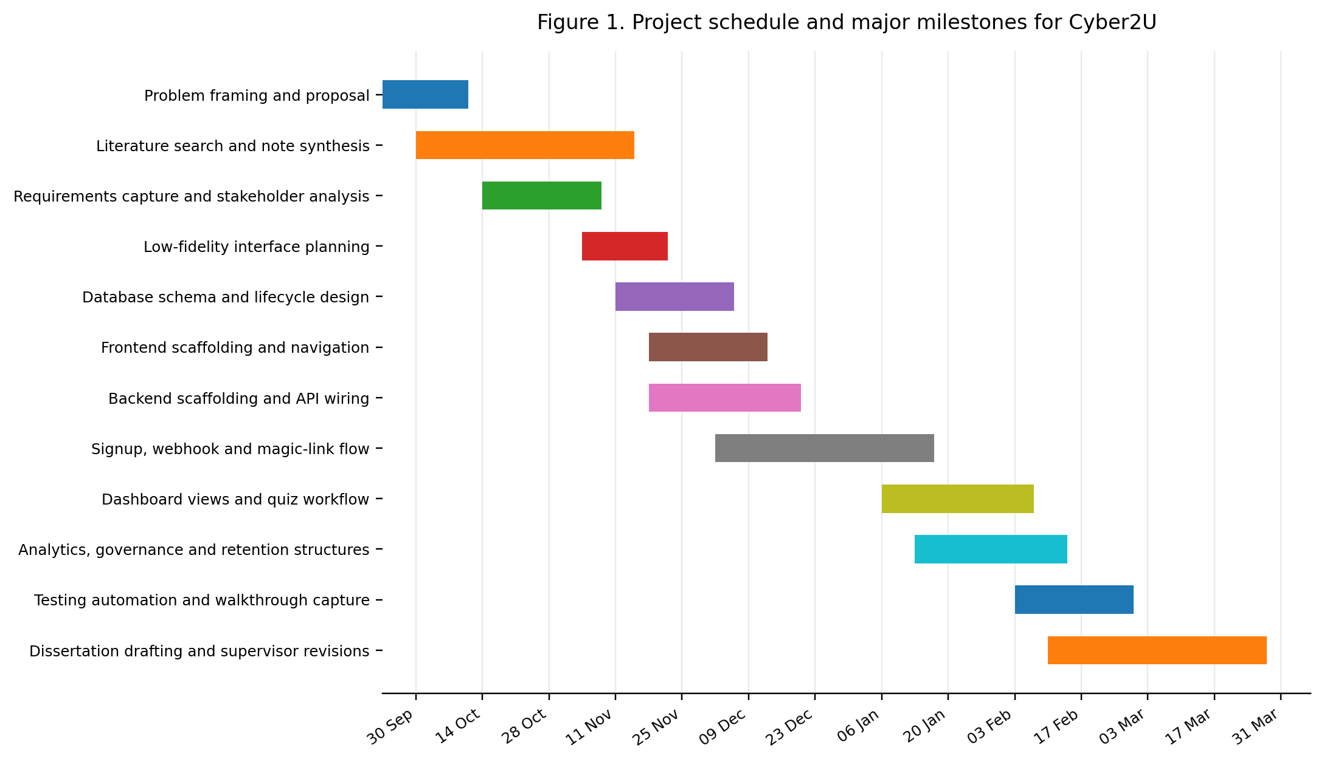
Figure 1 Project schedule and major milestones for Cyber2U

2.3 Milestones and deliverables
Table 2 summarises milestone outputs and completion status. It is not merely a task list; it shows how each phase produced evidence needed by the next phase and by the final dissertation argument.
Milestone | Indicative period | Primary output | Status
Proposal and problem framing | TB1 early phase | Project rationale, aims, risks and initial work plan | Completed
Research and requirements | TB1 mid phase | Literature synthesis, success criteria and requirements set | Completed
Architecture and data design | TB1 to TB2 transition | Database schema, route responsibilities and interface plan | Completed
Core learner implementation | TB2 early phase | Signup, verification, dashboard, quiz and review flow | Completed
Governance and analytics structures | TB2 early phase | Consent, deletion, retention and analytics-related entities | Partially completed
Testing and evidence capture | TB2 mid phase | Playwright configuration, screenshots and walkthrough artefacts | Completed
Report refinement and critical review | TB2 late phase | Finished dissertation, appendices and viva preparation | Completed
The milestone sequence also reveals iteration and dependency management in practice: learner-path delivery was prioritised first, then governance/analytics extensions, followed by validation evidence and report consolidation. This sequencing reduced the risk of producing a broad but weakly evidenced prototype.

2.4 Risk management and scope control
The risk register in Table 3 combines technical and academic risks because both affected deliverability. Several risks partially materialised: administrative scope remained weaker than learner workflows, evidence quality required late reinforcement through scripted captures, and writing pressure increased near submission. The table therefore functions as post-hoc evaluation as well as planning artefact by linking risks to mitigation decisions and observed outcomes.
Risk | Potential effect | Mitigation strategy | Outcome
Scope expansion into full enterprise admin tooling | Delayed completion and weak main workflow | Prioritised learner journey and deferred non-essential admin depth | Core learner path completed; admin path remains partial
Lack of repeatable evidence | Difficulty defending implementation in report and viva | Used screenshots, mailbox inspection and Playwright tooling to capture reproducible artefacts | Feasibility evidence improved
Security decisions left unexamined | Prototype may look complete while hiding major residual risks | Added dedicated cybersecurity and privacy analysis chapter | Residual risks explicitly documented
Insufficient time for writing | Technically sound artefact paired with weak report structure | Moved technical dumps to appendices and wrote against handbook headings | Report alignment improved

The most consequential management decision was deliberate scope control: deferring enterprise-level administration preserved time for core learner feasibility evidence. However, this trade-off also limits claims about organisational readiness and is treated explicitly in later evaluation chapters.

3. Literature Review
The literature review positions Cyber2U as an artefact that must be theoretically justified, not merely implemented. The chapter therefore evaluates where prior work supports the design and where evidence remains weak, contested or context-dependent.
Three themes structure the synthesis: human factors in security behaviour, retrieval-based learning design, and privacy-aware platform governance. Each theme is interpreted through explicit design implications and trade-offs so that the review remains analytical rather than descriptive.

3.1 Cybersecurity awareness and human factors
Research in usable security argues that users should not be treated as the weakest link in a purely moral sense; rather, systems should be designed so that secure behaviour fits normal work practice. Sasse, Brostoff and Weirich argue that security failures are often produced by poor fit between controls and human behaviour, not merely by ignorance. This perspective is relevant to Cyber2U because awareness tooling that is cumbersome or infrequent may fail before the learner even reaches the educational content.
Public breach reporting underscores the practical relevance of awareness work. The UK Cyber Security Breaches Survey (DSIT, 2024) and Verizon DBIR (Verizon, 2024) both report persistent phishing and credential-related attack vectors. These sources justify the problem context, but they do not validate Cyber2U outcomes directly; they establish why a repeatable intervention is worth investigating.
Existing awareness products frequently emphasise enterprise management, phishing simulation and reporting at scale. That makes sense in mature organisations, but it can create a gap for smaller institutions or early-stage teams where simplicity, cost and learner accessibility matter more than extensive administrative orchestration. Cyber2U therefore explores a reduced design space in which the core learner journey receives priority and the interface remains narrow enough to be feasible as an individual project artefact.

3.2 Retrieval practice, spacing and feedback
Educational research supports retrieval practice as a mechanism for strengthening memory (Roediger and Karpicke, 2006). However, laboratory retention gains do not automatically transfer to real phishing detection under stress, distraction or workload pressure; this is a key validity caveat for awareness-system design.
Spacing and repetition are similarly important (Kornell and Bjork, 2008; Murre and Dros, 2015). Cyber2U operationalises this through recurring weekly prompts, yet email-based delivery introduces trade-offs: reminders may improve recall for some users while contributing to habituation or message fatigue for others.
Feedback quality affects whether assessment becomes a learning event rather than a mere score-reporting exercise. Hattie and Timperley argue that useful feedback answers three questions: where the learner is going, how the learner is currently doing, and what should happen next. This framework supports Cyber2U’s use of review screens, per-session scoring, improvement overlays and topic mastery indicators. The dashboard is not included for decorative analytics; it exists because feedback must be visible and interpretable if the system is to support learning.

3.3 Motivation, self-efficacy and interface design
Bandura’s work on self-efficacy suggests that repeated successful performance can increase confidence in dealing with future tasks. In the context of cybersecurity, this implies that small correct decisions and visible progress may be useful in helping users feel capable of identifying threats. Cyber2U reflects this by foregrounding incremental progress rather than pass or fail status alone.
At the same time, motivational design must avoid unnecessary cognitive load. Sweller’s work on cognitive load and Mayer’s work on multimedia learning both caution against cluttered presentation and excess information competing for attention. This is relevant to Cyber2U because dashboards and progress charts can easily become visually noisy. The presence of an overcrowded improvement overlay in the current artefact, discussed later in the report, shows that even a theoretically justified visualisation can underperform if its design is not sufficiently restrained.
Self-determination perspectives are also relevant. Deci and Ryan suggest that autonomy, competence and relatedness matter for intrinsic motivation. Cyber2U does not attempt to build a full social-learning environment, but the option to choose or prioritise interest areas in the interface points toward a more autonomy-supportive approach than fixed uniform content alone.

3.4 Authentication usability and privacy-aware analytics
Awareness platforms are educational systems, but they are also operational software that must authenticate users and store data. Bonneau et al. argue that authentication schemes should be judged not only by security but also by usability and deployability. This is a strong justification for exploring passwordless magic-link access in a small awareness platform, because removing password storage can reduce friction and simplify onboarding.
However, authentication convenience can introduce other risks. If email becomes both the awareness channel and the authentication channel, the platform inherits trust assumptions about the inbox. It must also consider token expiry, replay resistance, CSRF protection, content security policy and session storage. This means that passwordless access is not automatically the superior choice; it is a trade-off that must be justified in context.
Analytics raises a similar tension. A platform intended to measure engagement and progress requires behavioural data, but over-collection undermines proportionality and user trust. GDPR-aligned principles therefore shape architecture choices at design stage (ICO, 2024), while operational compliance remains a future deployment responsibility rather than a claim made by this report.

3.5 Design implications derived from the literature
Table 4 synthesises the literature into design implications and explicit trade-offs. This format is used to move from what prior papers report to what those findings mean for concrete Cyber2U design decisions.
Literature insight | Design implication in Cyber2U | Trade-off / limitation
Retrieval practice improves retention compared with passive review (Roediger and Karpicke, 2006). | Prioritise short recurring quizzes with immediate review rather than static awareness pages. | In-app recall performance may not transfer to real incidents without contextual stressors.
Spacing supports longer-term recall when reinforcement is repeated over time (Kornell and Bjork, 2008). | Use weekly interaction cadence and progress tracking rather than one-off annual activity. | Over-frequent prompts can produce habituation, reduced attention or disengagement.
Feedback quality and self-efficacy influence sustained learning behaviour (Hattie and Timperley, 2007; Bandura, 1977a). | Expose per-session scores, corrective feedback and topic trends to support competence cues. | Poorly designed visualisations can overload users and weaken interpretability.
Usable authentication must balance security, deployability and user friction (Bonneau et al., 2012). | Adopt passwordless email verification to reduce onboarding friction in a small-scale platform. | Trust shifts to inbox security; token and session hardening become higher priority.
Privacy-by-design requires proportional collection and accountable processing (ICO, 2024). | Model consent, retention, deletion and audit entities early in schema and service design. | Schema-level readiness does not prove operational GDPR compliance in production contexts.
Table 1 Literature-derived design implications for Cyber2U
Overall, the literature supports a recurring feedback-rich model and justifies the architectural direction of Cyber2U, but it also constrains claim strength. The review therefore leads to a feasibility-focused design rationale: the artefact can be justified as theoretically coherent, while effectiveness claims remain contingent on future real-user evaluation.

4. Methodology
Cyber2U is best understood as a design-science-oriented individual project with an evaluative component. The core contribution is an artefact intended to address a practical problem, yet the artefact is justified using prior theory, explicit requirements and structured critical review. This positioning is appropriate because the project does not claim to produce a broad sociological account of awareness behaviour, nor does it report a controlled experiment with participant data. Instead, it develops and critiques a proof-of-concept system.
The methodology combines four strands: contextual analysis, literature-informed requirements engineering, iterative implementation and evidence-led feasibility evaluation. In this submission, the empirical strand is implemented as a reproducible synthetic simulation protocol (20 automated learner journeys) rather than a formal human-subject participant study. This distinction is explicit throughout the report so that claims remain aligned with available evidence.

4.1 Requirements elicitation
Requirements were derived by tracing each objective back to literature-backed design logic and then forward to implementable system behaviour. For example, retrieval-practice evidence motivated quiz/review requirements, while usability-security literature motivated low-friction authentication and explicit session controls.
Table 5 presents this requirement chain explicitly: objective -> literature rationale -> design decision -> implementation status. Functional requirements cover the learner journey and analytics pathways; non-functional requirements cover security, privacy, maintainability and testability needed for feasibility credibility.
Category | Requirement | Rationale (literature/design link) | Status
Functional | User signup and email verification | Low-friction access supports usable security in early-stage adoption contexts (Bonneau et al., 2012). | Implemented
Functional | Weekly quiz participation and review | Retrieval practice with immediate correction supports stronger recall than passive reading (Roediger and Karpicke, 2006). | Implemented
Functional | Dashboard with progress indicators | Visible feedback supports self-efficacy and reflection (Hattie and Timperley, 2007; Bandura, 1977a). | Implemented
Functional | Administrative analytics support | Analytics pathways are needed to evaluate delivery performance and prioritise future interventions. | Partially implemented
Non-functional | Security of sessions and tokens | Session and token controls are required to keep usability gains from undermining security posture. | Partially addressed
Non-functional | GDPR-aware data handling | Governance controls reflect GDPR-oriented minimisation and accountability principles (ICO, 2024). | Addressed in model and partial logic
Non-functional | Maintainability and testability | Typed contracts and automated tooling reduce regression risk during iterative solo development. | Addressed through typed stack and tooling
Table 2 Functional and non-functional requirements used to guide implementation
The requirements table shows feasibility coverage rather than impact proof: implemented status indicates whether capabilities exist, while effectiveness remains an empirical question for future real-user studies.

4.2 Success criteria
Success criteria are aligned with the measurable objectives in Section 1.2. Early ambitions about improved awareness and satisfaction are retained as impact hypotheses, but the assessed criteria in this dissertation are feasibility-oriented and metric-linked.
Feasibility success is judged against explicit thresholds: high completion of scripted learner journeys, complete persistence of score/progress metrics, and observable governance/analytics readiness. Impact success asks whether real users retain knowledge and change behaviour over time; this remains out of scope for the current synthetic evidence base.

4.3 Evidence and evaluation method
The evaluation uses three reproducible evidence classes: workflow captures, repository-level test/tooling configuration, and measurable interface outputs. Synthetic evaluation is appropriate here because the dissertation question is feasibility-oriented and the evidence can be regenerated from committed scripts.
No live participant study data, SUS questionnaire or pre/post cohort results were supplied as part of the dissertation materials. Synthetic evidence is therefore treated as methodological scaffolding: it validates instrumentation and reporting pathways but cannot establish causal learning impact, external validity or long-term behavioural change.

4.4 Simulation protocol and generated evidence corpus
A scripted evaluation pipeline was executed against the running Cyber2U stack. The protocol generated 20 synthetic learner accounts, applied varied journey variants (weekly-focused, monthly-focused, interest-customization, mixed-flow), executed dashboard and quiz interactions, captured screenshots, and submitted one feedback response per journey.
Evidence artifacts generated by the protocol include: synthetic_feedback_dataset.json, synthetic_feedback_dataset.csv, 20 feedback forms, and 40 usage screenshots (dashboard plus quiz per synthetic learner). These were produced through committed project scripts and are reproducible within the repository toolchain.

4.5 Ethics and transparency statement
This dissertation does not claim a completed human-subject participant study in the present phase. All newly generated responses and charts are explicitly labelled synthetic. The purpose of this evidence is engineering and methodological validation of the artefact pipeline, rather than inference about real participant populations.

4.6 Simulation limitations
Synthetic responses do not capture real motivation, misunderstanding, fatigue, social context, or longitudinal behaviour change. Satisfaction and recommendation values in this phase therefore reflect scripted distributions rather than observed sentiment. A future phase with recruitment, consent and ethics governance is required for participant-level efficacy claims.

5. Implementation
The implementation follows a three-tier pattern consisting of a React and Vite frontend, an Express and TypeScript backend, and PostgreSQL for persistence. This stack was appropriate for an individual final-year artefact because it supports rapid iteration, typed contracts across components and a conventional separation between presentation, business logic and stored records.
The frontend is responsible for route-based navigation, view composition and user interaction. The backend mediates verification, quiz submission, scoring logic, analytics aggregation and governance-related actions. The database stores users, quiz activity, progress snapshots, campaign-oriented records and data-governance entities. This architectural split helps make each concern visible in both the codebase and the report.

5.1 Core learner workflow
The implemented learner path begins when a user submits an email address. Instead of creating a reusable password, the system issues a verification or sign-in link. This reduces password-storage obligations and lowers the friction of first use. Once verified, the learner is taken into a dashboard where completion counts, average scores, improvement measures and topic indicators are shown.
The quiz workflow is intentionally short. A learner launches a weekly quiz, answers a set of scenario-based or knowledge-based items, submits the responses and receives question-by-question corrective feedback. The dashboard and improvement overlay then provide a cumulative reflective layer. This sequence was designed to turn assessment into reinforcement rather than treating the quiz as a detached score event.

5.2 Implementation workflow in practice
In practice, implementation progressed from the data model outward. The database schema and lifecycle design provided a stable frame for later features such as consent records, deletion requests and progress snapshots. Backend scaffolding then added route and service structure, after which the frontend was refined to expose the learner journey in a coherent visual sequence.
The most substantial completed work appears on the learner side. Signup, login, verification, dashboard display, quiz participation and review flow all have visible artefact evidence. By contrast, the administrative content pipeline remains shallower. The original material describes campaign creation, approval and reporting logic, but those pathways are not demonstrated with the same degree of end-to-end evidence in the current artefact.

5.3 Why email-first?
Email was selected because it is already embedded in the daily routines of both learners and administrators. This makes email attractive as an awareness channel: it removes the need to persuade users to adopt an entirely new communication medium and allows prompts to arrive asynchronously. For student and SME contexts this can be an important practical advantage.
However, the choice is not risk-free. Email is also the medium through which phishing is commonly attempted, and reliance on inbox attention can create deliverability and trust problems. The design therefore offers convenience at the cost of dependency on a channel that itself demands good security judgement from users. That tension is central to the project rather than incidental to it.

5.4 Data model and governance structures
The underlying data model is broader than a minimal quiz prototype. In addition to identity and quiz activity, the design includes user consents, sessions, progress snapshots, campaign deliveries, audit logs, data retention policies and deletion requests. This matters because it demonstrates that the project considered the life cycle of learner data rather than treating data storage as a purely functional concern.
Modelling these entities also supports later evaluation and governance. If an awareness system intends to show improvement, completion or campaign performance, then the system needs a coherent persistence strategy for those records. At the same time, such measurement must be kept proportionate so that analytics does not become surveillance. The data model was therefore framed to support evidence and accountability together.

5.5 Illustrative interface states
Figures 2 to 6 illustrate the implemented learner journey and supporting development evidence. These figures are referenced again in the evaluation chapter because they function as direct artefact evidence rather than as decorative screenshots.
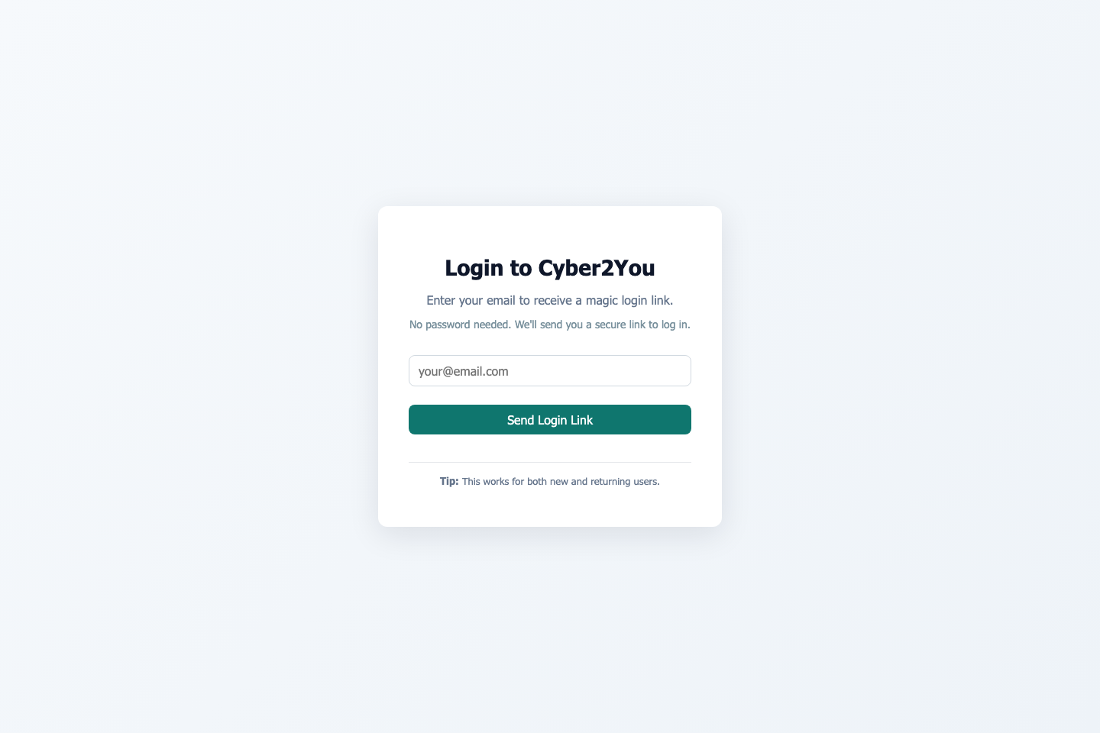
Figure 2 Login screen for Cyber2U
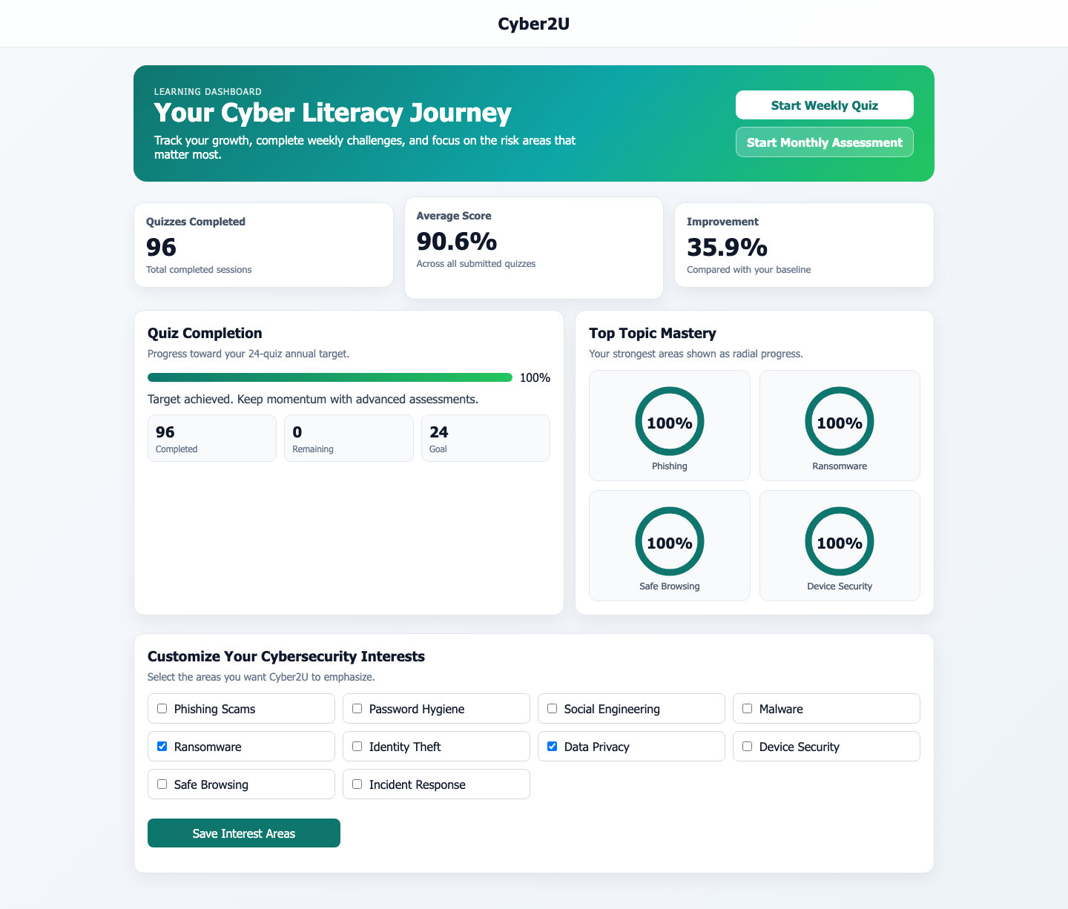
Figure 3 Learner dashboard showing completion counts, average score, improvement and topic indicators

Figure 4 Weekly quiz screen in progress
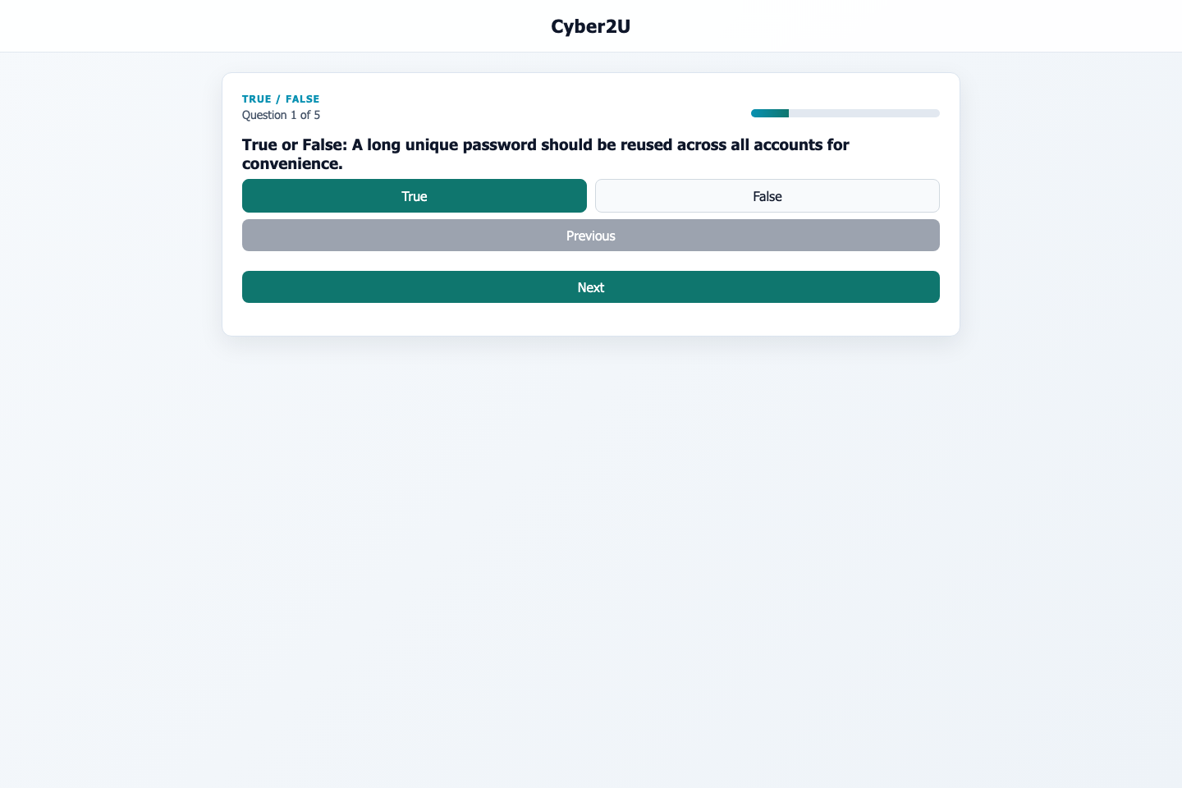
Figure 5 Review overlay showing a recorded weekly score of 71.4 per cent

Figure 6 Weekly quiz email rendered in the development mailbox environment

6. Cybersecurity, Privacy and Compliance Analysis
Cyber2U processes identifiable user information and uses email links as an access mechanism. Security therefore forms part of the core research question rather than a peripheral implementation topic. A system intended to improve cyber literacy would be contradictory if it exposed users to avoidable token abuse, excessive data collection or unclear consent flows.
A lightweight threat model is useful here because it makes design assumptions explicit. The goal is not to claim formal assurance, but to identify which assets are being protected, which abuse cases are plausible and which mitigations are present or still incomplete.

6.1 Threat model
Threat | Asset at risk | Mitigation present in current design | Residual concern
Token theft or replay | Learner accounts and session integrity | Short-lived verification links, server-side verification logic, rate limiting and HTTPS-ready deployment assumptions. | Compromised inboxes still reduce resistance in a passwordless model.
Cross-site scripting | Session tokens and dashboard data | Use of React reduces direct DOM manipulation; security middleware is present in the stack. | If tokens are stored in localStorage, successful XSS could expose sessions.
Cross-site request forgery | State-changing actions | CSRF is identified as a project security requirement. | Implementation detail needs explicit verification in production.
Excessive or retained personal data | Compliance posture and learner privacy | Retention policies, deletion requests and audit records are modelled. | Operational enforcement is only partially evidenced.
Admin misuse or overexposure of learner data | Organisational trust and fairness | Role separation is implied in the design and analytics is not publicly exposed. | Administrative path is incomplete and requires stronger RBAC validation.
Table 3 Lightweight threat model for the Cyber2U platform

6.2 Privacy, GDPR and data minimisation
The data-protection posture of the project is one of intentional support rather than overclaiming. Consent, deletion, audit and retention are represented in the system design because a learning platform can process information that becomes sensitive when linked to identity and performance. This is especially relevant in educational and employment contexts, where poor analytics design could create reputational or pastoral concerns.
The design follows a proportionality principle: collect enough information to support access control, quiz feedback and campaign reporting, but avoid unnecessary public exposure or intrusive ranking. The absence of public leaderboards and the inclusion of deletion requests are both consistent with that principle. However, a compliant schema is not the same as a compliant deployment. True compliance would depend on operational behaviour such as meaningful consent wording, working erasure routines, secure backups and controlled access to reports.

6.3 Justification of key security decisions
Passwordless magic-link authentication is defensible in this context because it lowers onboarding friction and removes one major storage burden: password handling. For a lightweight awareness platform, that trade-off can be justified if token expiry is short, replay is prevented and inbox trust assumptions are clearly understood.
The most significant unresolved question concerns session storage. If client-side tokens are retained in localStorage, the system becomes more vulnerable to XSS-driven session theft than an equivalent design based on HttpOnly, Secure cookies with explicit CSRF protection. The report therefore treats localStorage persistence as a pragmatic prototype choice rather than as the final recommended production posture.
A further design decision concerns analytics. Learning interventions require some evidence if they are to be evaluated, yet evidence collection can easily drift into over-monitoring. Cyber2U attempts to balance these pressures by keeping the analytics layer focused on delivery, completion and progress rather than on broad behavioural surveillance. That balance would need continued scrutiny in any future deployment.

6.4 Legal, social and licensing considerations
Beyond data protection, the project also raises social and governance considerations. Awareness platforms can influence how organisations perceive and judge their users. If reporting is used punitively, then the platform could undermine trust rather than improve behaviour. This is why the report consistently frames analytics as support for learning and operational insight, not as a mechanism for public ranking or embarrassment.
From a licensing and implementation perspective, the chosen stack relies on established open-source components that are common in web development. A production deployment would still need a routine dependency-review process and a formal record of third-party licences, but no evidence in the supplied materials suggests that the project depends on unusual or incompatible licensing arrangements.

7. Evaluation
The evaluation chapter focuses on what can be shown honestly from the available evidence. No live participant cohort, no SUS dataset and no longitudinal deployment logs were supplied with the dissertation materials. The evaluation therefore concentrates on feasibility: whether the artefact functions coherently, whether the workflow can be evidenced and whether the outputs observed in the interface support the claims made about implementation.
The evaluation has three layers. First, functional walkthrough evidence asks whether the end-to-end learner journey can be observed. Secondly, tooling evidence asks whether the project includes repeatable validation mechanisms. Thirdly, measured artefact outputs ask whether the interface demonstrates working calculations and stored progress. These forms of evidence are limited, but they remain preferable to speculative reporting.

7.1 Functional walkthrough results
Workflow stage | Observed evidence | Result | Interpretation
Login and entry | Login screen shown in Figure 2. | Pass | A clear entry point exists for the learner journey.
Dashboard rendering | Dashboard shown in Figure 3 with completion count, average score and improvement. | Pass | The platform surfaces cumulative learner metrics successfully.
Weekly quiz participation | Quiz-in-progress shown in Figure 4. | Pass | Interactive assessment content is present and navigable.
Review feedback | Review overlay shown in Figure 5 with score and correction context. | Pass | Immediate corrective feedback is implemented.
Email delivery | Rendered weekly quiz email shown in Figure 6 and development mailbox screenshot available in appendix material. | Pass | Email-based delivery is demonstrably linked to the artefact.
Administrative operation | Described in design materials but not shown through complete end-to-end evidence. | Partial | The admin side remains materially weaker than the learner side.
Table 4 Functional walkthrough results for the implemented learner workflow

7.2 Testing and tooling evidence
The repository configuration provides further support for the claim that Cyber2U moved beyond pure concept stage. The backend package includes Jest scripts, while the frontend package includes Playwright end-to-end tooling and a configuration that captures screenshots, traces and retained video. The README also identifies the screenshots and walkthrough artefacts as Playwright-generated outputs.
These details do not by themselves prove comprehensive test coverage, but they do matter academically because they show that the project was developed with some repeatable validation in mind. For a final-year proof-of-concept artefact, the presence of automated browser tooling is a meaningful sign of engineering maturity.
Evidence source | Observed fact | Evaluation meaning
Backend package configuration | Jest scripts are defined for testing and watch mode. | The backend is structured to support repeatable validation.
Frontend package configuration | Playwright scripts are defined for end-to-end testing. | Browser workflow verification is part of the development strategy.
Playwright configuration | Local server launch, trace capture, screenshots and retained video are configured. | Validation evidence can be reproduced more reliably than through manual narration alone.
README and appendix evidence | Screenshots and walkthrough artefacts are described as generated from a Playwright run. | At least one coherent automated walkthrough was completed successfully.
Table 5 Test and tooling evidence associated with the Cyber2U artefact

7.3 Measured artefact outputs
The values visible in the interface appear to be seeded or demonstration data, yet they are still real outputs from the running system and are therefore more defensible than hypothetical metrics. Table 6 summarises the main visible values used in this evaluation.
Observed metric from artefact | Interpretation
96 quizzes completed on the dashboard | Demonstrates that historical activity can be aggregated and rendered.
90.6 per cent average score on the dashboard | Demonstrates cumulative performance calculation.
35.9 per cent improvement on the dashboard | Demonstrates baseline-versus-current comparison logic.
71.4 per cent weekly score on the review overlay | Demonstrates per-session scoring and feedback persistence.
24-goal progress card at 100 per cent with 96 completed and 0 remaining | Demonstrates completion-target logic and progress rendering.
Table 6 Measured outputs visible in the implemented interface

7.4 Interpretation against objectives
Objective 1, improving awareness and sustained engagement, is partially supported. The platform clearly supports recurring contact and repeat interaction through email and quizzes. However, no live open-rate, click-through or retention dataset is available in the dissertation materials, so a claim of improved engagement would currently be premature.
Objective 2, assessing and improving learner knowledge, is also partially supported. The quiz engine, review flow and progress metrics show that the platform can measure knowledge-related outputs and present them coherently. What remains unproven is whether real users improve over time under realistic conditions.
Objective 3, supporting evaluation and future scale-up, is again partially supported. The architecture anticipates analytics, campaigns, governance records and retention management, which are all relevant to future scale. Yet those capabilities have not been load-tested and the administrative path remains incomplete.

7.5 Simulation results and charted outputs
The synthetic corpus (n = 20 journeys) yielded the following aggregate values: mean usability 4.0/5, mean content clarity 4.0/5, mean confidence-improvement 4.0/5, mean recommendation 8.0/10, and would-continue responses 16/20 (80%).
Three generated charts support direct evidence reporting: rating_distribution.png, recommendation_by_variant.png, and continuation_intent.png. Together, these visualisations demonstrate that the implemented data pathway can segment by journey type and summarise both scalar and binary feedback indicators.

7.6 Interpretation, ethics and validity boundary
These outputs support the claim that Cyber2U can capture, store and analyse mixed evidence types (ratings, qualitative comments and screenshots) through a reproducible pipeline. They do not, however, constitute proof of real participant learning outcomes. The results should therefore be interpreted as proof-of-concept simulation evidence with an explicit validity boundary.

8. Critical Review
The critical review brings together the strongest and weakest aspects of the project and reflects on what a marker, supervisor or viva panel is entitled to conclude. It is not sufficient that Cyber2U appears polished; the key question is whether the project demonstrates a credible contribution at the level expected of the module.
The strongest feature of the project is its coherence. The literature review does not sit apart from the system; retrieval, spacing, feedback and low-friction usability each map onto observable features of the learner workflow. This means the artefact is academically more defensible than a generic dashboard application with cybersecurity branding added afterwards.

8.1 Strengths
A second strength is the early incorporation of governance and privacy structures. Many student prototypes treat deletion, consent or retention as optional extras, yet in Cyber2U these features appear in the schema and design reasoning from the outset. That improves the credibility of the platform as a cybersecurity-related artefact.
A third strength is the level of engineering maturity visible in the submitted materials. The typed stack, clear route separation, database-backed design, automated testing configuration and captured walkthrough artefacts all indicate that the project progressed beyond a purely notional proposal.

8.2 Weaknesses and what did not work well
The central weakness is the gap between technical feasibility and empirical proof. The project can demonstrate that the workflow exists, but it cannot yet demonstrate with participant evidence that awareness or behaviour improved. In dissertation terms this is a significant limitation because learning impact remains one of the project’s core ambitions.
Some interface choices also require refinement. The improvement overlay, while useful as a proof of calculation, is visually crowded and makes topic-by-topic trends difficult to interpret. This weakens the usability value of the analytics layer and shows that visual evidence should not be confused with communicative clarity.
Administrative capability remains under-evidenced. Campaign scheduling, content approval and organisational reporting are described in design materials, but they are not demonstrated with the same confidence as the learner journey. A future iteration should close that asymmetry.

8.3 Rejected or deferred alternatives
A native mobile application was considered only at the level of future potential. While push notifications and richer device integration might improve engagement, a mobile build would significantly increase development and maintenance scope and would have threatened the deliverability of the core web artefact.
Traditional password-based authentication was also avoided. This reduced friction and removed password-storage obligations, which was beneficial for a proof-of-concept platform. The trade-off is that email security becomes more critical and the session model needs stronger hardening before production use.
Highly gamified mechanics such as public leaderboards were not prioritised. Such features might increase activity for some users, but they also risk demotivating weaker learners and exposing performance information inappropriately.

8.4 Limitations
Table 10 consolidates the principal limitations that constrain interpretation of the project outcomes. The purpose is to make the validity boundary explicit rather than implied.
Limitation | Why it matters
No live pilot or pre/post user study | Prevents strong claims about awareness gains or behavioural change.
Demonstration metrics appear seeded | Useful for interface verification, but not a substitute for real deployment evidence.
Admin functionality is incomplete or lightly evidenced | Reduces confidence in organisational adoption and operational readiness.
Security hardening is not exhaustively verified | Residual concerns remain around token storage, session handling and production headers.
Scalability is assumed rather than stress-tested | Performance under realistic campaign volume remains unknown.
Table 7 Principal limitations of the current Cyber2U artefact
The limitations are not peripheral: each one directly informs the future-work priorities, especially the need for real-user evaluation, stronger security hardening evidence and fuller administrative workflow validation.

8.5 Future work
The most valuable next step would be a small live pilot involving approximately five to ten users, using a short pre/post knowledge design and a brief usability questionnaire. Even a small but genuine dataset would move the project from pure feasibility toward early impact evaluation.
Technical future work should address session storage, cookie strategy, CSRF validation, content security policy, dependency review and role-based access control for administrative pathways. Interface refinement should also simplify progress visualisation so that the analytics layer communicates clearly without visual overload.
If the artefact were to progress toward organisational use, it would also need a more complete content-operations workflow, audit-ready reporting views and carefully controlled exports that minimise personal data exposure.

9. Conclusion
This dissertation has presented Cyber2U as a proof-of-concept artefact that addresses a practical cybersecurity-awareness problem through an email-first workflow.
The strongest conclusion that can be defended is one of technical feasibility supported by educational logic. Cyber2U demonstrates that an awareness platform can combine signup, verification, dashboard feedback, quiz interaction and governance-oriented data structures in a coherent web application. It also shows that privacy and security concerns were considered as part of the design rather than left as an afterthought.
The weakest area remains impact evidence. Without a live participant study, the dissertation cannot yet claim that the platform measurably improves long-term cybersecurity behaviour. That limitation does not invalidate the project; rather, it defines the next stage of work. With a small pilot, fuller administrative evidence and stronger hardening of the session model, Cyber2U could progress from a promising final-year artefact into a more convincing operational awareness platform.

References
Anderson, L.W. and Krathwohl, D.R. (eds.) (2001) A taxonomy for learning, teaching, and assessing: A revision of Bloom’s taxonomy of educational objectives. New York: Longman.
Bandura, A. (1977a) ‘Self-efficacy: Toward a unifying theory of behavioral change’, Psychological Review, 84(2), pp. 191-215.
Bandura, A. (1977b) Social learning theory. Englewood Cliffs, NJ: Prentice Hall.
Bloom, B.S., Engelhart, M.D., Furst, E.J., Hill, W.H. and Krathwohl, D.R. (eds.) (1956) Taxonomy of educational objectives: The classification of educational goals. Handbook I: Cognitive domain. New York: David McKay.
Bonneau, J., Herley, C., van Oorschot, P.C. and Stajano, F. (2012) ‘The quest to replace passwords: A framework for comparative evaluation of web authentication schemes’, 2012 IEEE Symposium on Security and Privacy, pp. 553-567.
Creswell, J.W. and Creswell, J.D. (2018) Research design: Qualitative, quantitative, and mixed methods approaches. 5th edn. Thousand Oaks, CA: Sage.
Deci, E.L. and Ryan, R.M. (1985) Intrinsic motivation and self-determination in human behavior. New York: Plenum Press.
Department for Science, Innovation and Technology (2024) Cyber security breaches survey 2024. London: HMSO.
Fogg, B.J. (2019) Tiny habits: The small changes that change everything. New York: Houghton Mifflin Harcourt.
Haladyna, T.M. and Rodriguez, M.C. (2013) Developing and validating test items. New York: Routledge.
Hattie, J. and Timperley, H. (2007) ‘The power of feedback’, Review of Educational Research, 77(1), pp. 81-112.
Kirkpatrick, D.L. and Kirkpatrick, J.D. (2006) Evaluating training programs: The four levels. 3rd edn. San Francisco: Berrett-Koehler.
Kornell, N. and Bjork, R.A. (2008) ‘Learning concepts and categories: Is spacing the enemy of induction?’, Psychological Science, 19(6), pp. 585-592.
Mayer, R.E. (2009) Multimedia learning. 2nd edn. Cambridge: Cambridge University Press.
Murre, J.M.J. and Dros, J. (2015) ‘Replication and analysis of Ebbinghaus’ forgetting curve’, PLOS ONE, 10(7), e0120644.
Roediger, H.L. and Karpicke, J.D. (2006) ‘Test-enhanced learning: Taking memory tests improves long-term retention’, Psychological Science, 17(3), pp. 249-255.
Sasse, M.A., Brostoff, S. and Weirich, D. (2001) ‘Transforming the weakest link: A human-computer interaction approach to usable and effective security’, BT Technology Journal, 19(3), pp. 122-131.
Sweller, J. (1988) ‘Cognitive load during problem solving: Effects on learning’, Cognitive Science, 12(2), pp. 257-285.
Verizon (2024) 2024 Data Breach Investigations Report. Available at: https://www.verizon.com/business/resources/reports/dbir/ (Accessed: 28 March 2026).
W3C (2018) Web Content Accessibility Guidelines (WCAG) 2.1. Available at: https://www.w3.org/TR/WCAG21/ (Accessed: 28 March 2026).

Information Commissioner's Office (2024) Guide to UK GDPR. Available at: https://ico.org.uk/for-organisations/uk-gdpr-guidance-and-resources/ (Accessed: 13 April 2026).

Appendix A. Additional Implementation Evidence
The appendix relocates image-heavy material away from the main argument while keeping the implementation demonstrable. The figures below support the evaluation chapter and may also assist viva presentation.
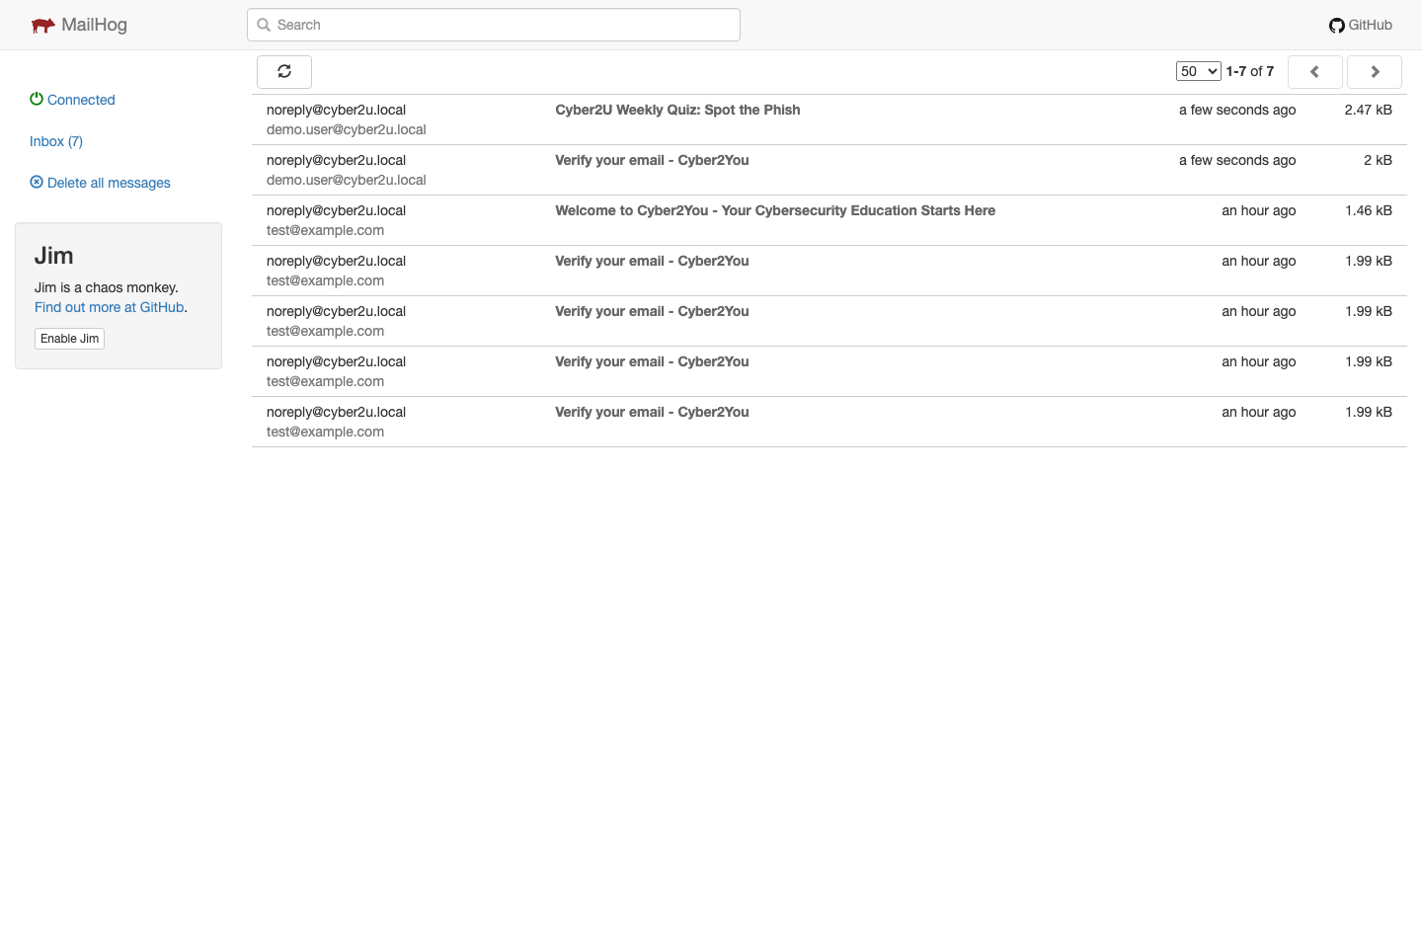
Figure 7 Development mailbox inbox showing outbound Cyber2U messages
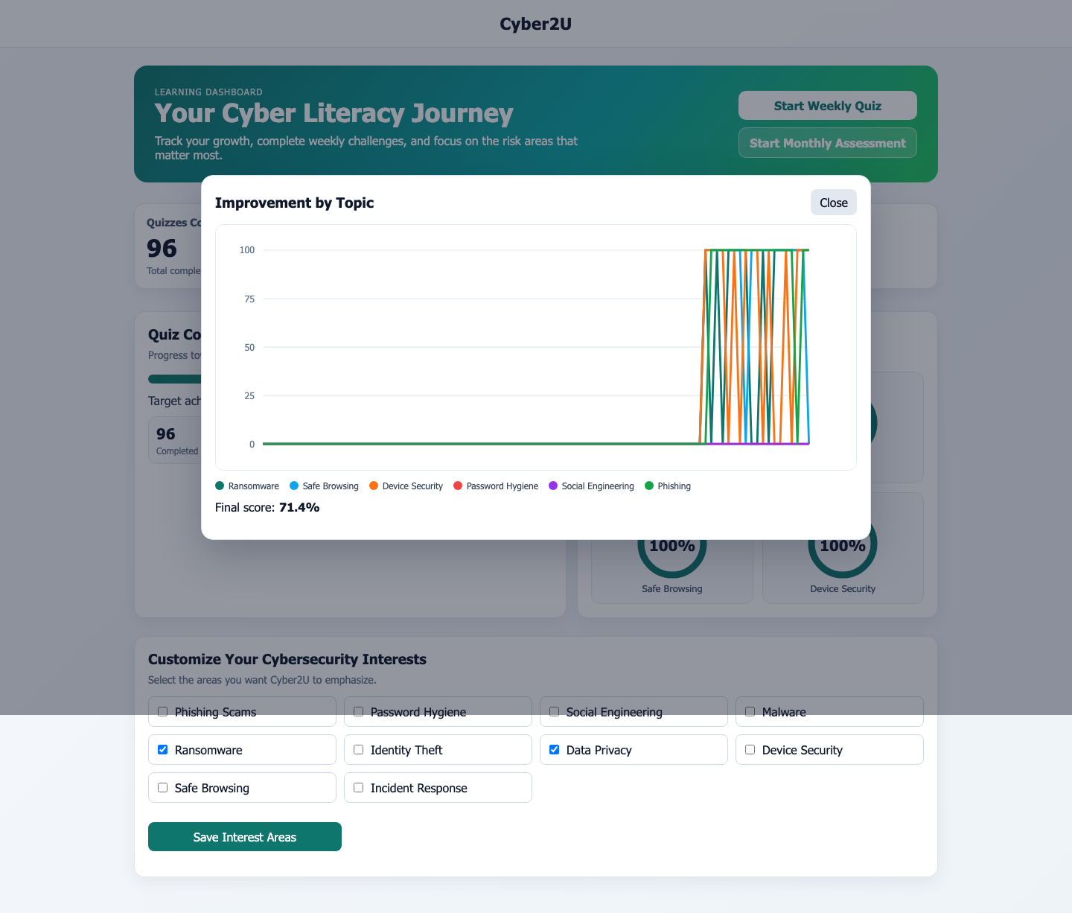
Figure 8 Improvement overlay by topic, illustrating both scoring logic and visualisation clutter

Appendix B. Condensed Technical Summary
Detailed endpoint lists, setup commands and full schema definitions were intentionally moved out of the main body so that the report remains academic rather than product-manual-driven. The summary below retains the most relevant technical details.
Area | Summary
Frontend | React 18, Vite and TypeScript; route-based learner interface; Playwright end-to-end tooling.
Backend | Express and TypeScript; JWT support, security middleware, rate limiting and email-delivery dependencies.
Database | PostgreSQL relational design supporting users, quiz activity, progress snapshots, governance records and analytics structures.
Email flow | Webhook or form-driven signup leading to verification email and dashboard entry.
Completed learner features | Login and verification flow, dashboard, weekly quiz interaction, review feedback and progress visualisation.
Partial or deferred features | Full admin content operations, production hardening, live pilot analytics and load testing.

Appendix C. Data and Governance Summary
The data design anticipates not only learning activity but also accountability. This appendix summarises the main entity groups and their purpose.
Entity group | Examples | Purpose
Identity and access | users, email_verifications, sessions | Support onboarding, verification and controlled access.
Learning activity | quiz_questions, quiz_attempts, quiz_sessions | Store interaction, scoring and correction data.
Progress and analytics | user_progress_snapshots, campaign_deliveries, campaign_analytics | Support longitudinal insight and future organisational reporting.
Governance and compliance | user_consents, audit_logs, retention policies, deletion_requests | Support accountability, erasure handling and retention control.

